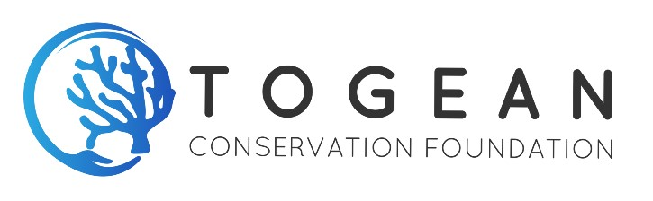
Intern Application Form
Important Information
Before completing the form, please read in detail the intern role description and ensure that you meet the skills, qualifications and time commitment required. We apologise that we will not be able to reply to applications from interns that do not meet the necessary criteria or commit for the required duration. Application fees are non-refundable, so please check with us before applying if you are not sure if you meet the criteria. You may apply for more than one position using this form, provided you meet the requirements. In this case, you only need to pay one application fee. Applicants must be aged 18 or over.

Please complete all questions on the form and once complete, email it with all the requested documents attached to togeanconservation@gmail.com. You are welcome to attach your CV/Resume in support of your application but you will still need to answer all the questions on the form.

Applicant name:
Nationality:
Please let us know how we can contact you:
Email address (if you have one):
WhatsApp number(if you have one):
Telephone number including international code:
Intern Position(s) you wish to apply for:
What date would you be able to start:
What is the proposed duration of your internship?:
What are the specific requirements of your internship (guidelines, etc)?:
Name of learning institution:
Address of learning institution:
Your course title:
Learning institute contact name (internship coordinator):
Learning institute contact email and telephone:
Are you applying to work remotely or on site:
Languages spoken and level (i.e. basic, intermediate or fluent):
Tell us about any relevant qualifications you hold:
Tell us about any relevant qualifications you are currently working towards and how far through your course you are:
It is important that you demonstrate on this form that you have the necessary skills to carry out the role(s) otherwise you may not receive a reply. Please tell us about the relevant skills you have and where and when you obtained these skills:
Tell us about what you hope to gain by interning with TCF:
Tell us about what you hope to contribute by interning with TCF:
Have you ever been convicted of an offence? Yes / No
If yes, please give us the details – when, where, what was the offence, and the outcome?
Are you connected to any other intern or volunteer applicants, for example partner, fellow student, or travel buddy that you wish to Intern with? Yes / No
If yes, please give us the name(s) of the other applicants you are connected to and the position(s) they are applying for:
Do you have any special physical, medical or psychological requirements that we may need to consider in terms of how to best to facilitate or support your involvement? Yes / No
If yes, please tell us what support or facilities you would need:
Do you have previous experience of interning or volunteering? Yes / No
If yes, please tell us where, when and with whom (organisation name) and a brief description of your role or duties:
Do you have previous experience of being in a tropical environment if applying to work on-site? (If applying to work remotely just answer with N/A.) Yes / No
Do you require a visa to enter Indonesia? (If Indonesian citizen, answer No) Yes / No
Have you read our vision, mission, values and approach and are satisfied that you can work towards these? Yes / No
Please supply the names and email addresses/telephone numbers or 2 referees who can provide a reference for you. These can be previous employers, previous internship or volunteer placement providers, or university or school representatives if you have no previous work or intern experience.
First Referee
Name:
Email:
Position or role:
Organisation or company name:
Telephone including international code:

Second Referee
Name:
Email:
Position or role:
Organisation or company name:
Telephone including international code:

Some posts may require us to undertake a criminal background check (for example, if working with young or vulnerable people or if handling finances on behalf of TCF). Do you consent to a criminal background check, if necessary? Yes / No

Additional Information
In order for us to accept your application, we require payment of the intern application fee, unless you are a local resident of Togean Islands or Ampana. Please make this payment using the form on the intern and volunteer application page on our website:
https://www.togeanconservation.com/volunteer-application-forms
Application fees are as follows:
For non-Indonesian interns – IDR100,000
For Indonesian interns from outside Togeans/Ampana – IDR50,000
If you are a non-Indonesian National, please send us a copy of the main page of your passport (with your name details, passport expiry date, etc).
If you are an Indonesian National, please send us a copy of your KTP (national identity card)
Please note on-site interns are required to have medical insurance that covers the duration of the internship and all the activities and duties included within the role description, unless you hold a health card entitling you to use Indonesian Health Services that covers any potential necessary treatment (Indonesian nationals only). You will be asked for a copy of your insurance certificate once accepted as an Intern. It is your responsibility to arrange and pay for your own travel health insurance. Indonesian Nationals should send us a photo or copy of their health card.
Intern Application Checklist
Application form completed Yes / No
Copy of passport or KTP included Yes / No
Vision, mission, values and approach read and agreed Yes / No
Proof of payment of application fee included Yes / No
Willing to take out medical insurance for the duration Yes / No / NA
or
Photo/photocopy of Indonesian health card included Yes / No / NA

